AATC_NoFlyZoneGrapher
The AATC_NoFlyZoneGrapher module handles transferring the NoFlyZones from the database to the graph files. The program takes each NoFlyZone, finds the volume which the NoFlyZone spans and sets the cost of the node to the maximum of the NoFlyZones which cover that area or 1 if 0 NoFlyZones cover this area.
The procedure would be similarly memory intensive to creating the graph as in order to ensure that all NoFlyZones are removed which are no longer in existence the entire graph would have to be loaded into memory. To prevent this the graph nodes are flushed every N nodes to prevent a build-up of unused nodes in memory. As the DynoGraph object loads nodes in full blocks from memory this means that nodes which were not altered will also be loaded into memory and successfully saved , therefore nodes which where saved but not altered will not be lost.

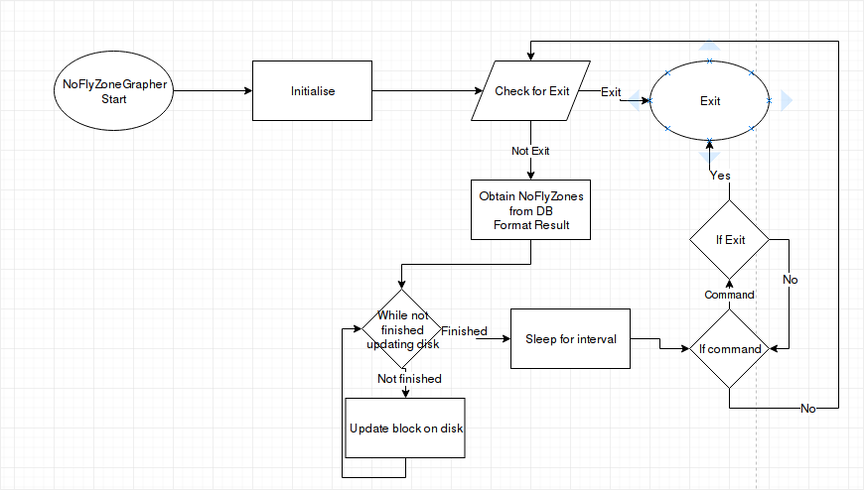

Import
The AATC_DB module is required to load the NoFlyZones from the database. The AATC_Astar module is required to use the Graph files. Ast is used to convert messages from the database into lists. The Time module is required to ensure the correct graph is being used. AATC_Coordinate is used to create coordinate objects to simplify work with the NoFlyZones.

NoFlyZoneGrapher_Launch
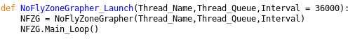
The NoFlyZoneGrapher_Launch procedure is used to launch the no fly zone grapher. The function takes the same arguments as the class and passes these to the class when created. The the class main loop is called. This is used by the server starter to start the no fly zone grapher.

NoFlyZoneGrapher
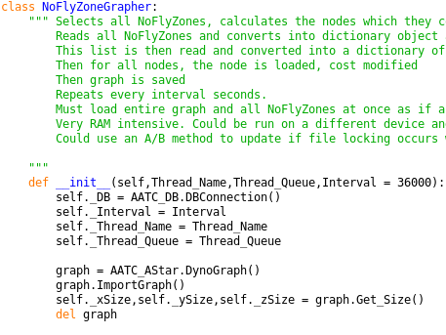
The NoFlyZoneGrapher class is used to manage all things regarding the conversion of the NoFlyZone database entries to the Graph files. The instantiation of the object takes two main parameters, Thread_Name and Thread_Queue, which are given from the Thread_Controller and allows identification of the process and control over the process. The optional integer Interval parameter governs how frequently the NoFlyZone grapher should run ( as the operation cannot run on the fly when new NoFlyZones are added the system must run every X seconds, this value governs this behaviour. Depending on the server load and the response time desired the Interval should be adjusted ( the Grapher may consume noticeable amounts of memory and therefore impact other processes)).
Firstly a DB connection is created and then the attributes of the Grapher are added. A graph is created and imported in order to obtain the sizes in each dimension of the graph, then the graph is deleted.

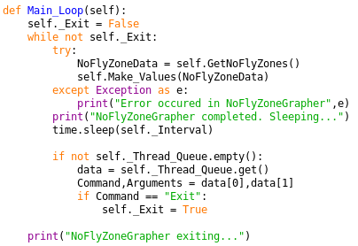
The Main_Loop method is used to run the main program of the NoFlyZoneGrapher. The program loops until it is told to exit. For each loop the program obtains the NoFlyZone data and calls the MakeValues method to write out these values. Should an exception occur it will be caught in the try/except statement and the program will continue. The program then sleeps for Interval seconds and then continues, preventing the Grapher from permanently writing data to the disk. The program then checks if a new command is available in the queue, if there is it will obtain the command and arguments and execute the relevant command, currently only exit, which then exits the program. Once the program finally exits an exit message is displayed.

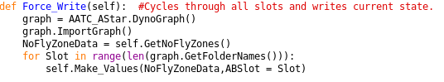
The Force_Write method is used to force the Grapher to write the NoFlyZones to all graph copies rather than the one it is supposed to. A graph is created and imported in order to get all the possible folder names. The NoFlyZone data is obtained. The program then loops through each possible graph slot (place where the graph copy could be saved) and writes the new information to this copy. This could be used if the server needs to force the change immediately i.e. reverse an error.

The Mod function is used to obtain the modulus in each dimension for a Coordinate. The modulus is used to calculate which nodes lie in the cuboid area created by two coordinate points.

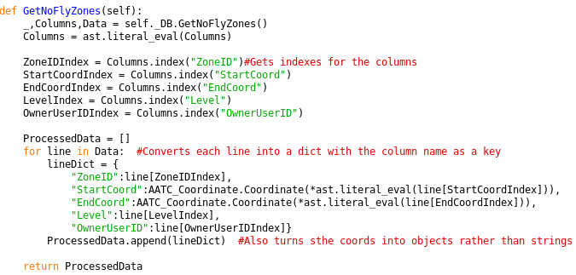
The GetNoFlyZones method is used to obtain the processed data containing the details of all NoFlyZones on the server. This data in the form of dictionary is used to easily use the details of the NoFlyZones throughout the rest of the program. First the NoFlyZones are obtained from the database, the columns are converted to a list containing the column headings of the table. These details are used to obtain the indexes of each component of the NoFlyZones such as ZoneID, Level and coordinates. A processed data list is created and the program iterates through each NoFlyZone result from the database request, converting each line into a dictionary using the indexes , the dictionary is then added to the processed data list. This list is then returned.

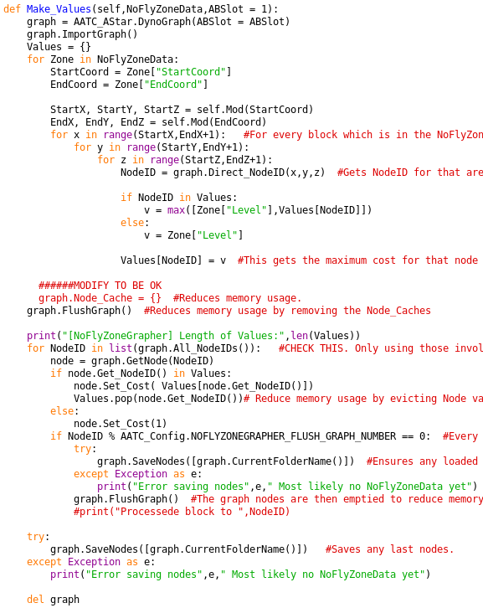
The Make Values method is used to write the processed NoFlyZone values to the graph files. The method takes the list of dictionaries NoFlyZoneData argument as well as the ABSlot argument which specifies which graph copy should be written to ( see AATC_Astar for more detail).
The graph is created and loaded with the relevant ABSlot. A Values dictionary is created , used to mark which NodeIDs are to be set to which value, with the NodeID:Cost pair. The program then proceeds to iterate through each zone in the processed data, The Start and End coordinates are obtained and the Modulus of each Coordinate is calculated. The moduli tell the system how many items across from each axis the node is, allowing the program to iterate through each axis from the Start to end modulus. This generates the x,y,z moduli for all the nodes in the NoFlyZone, which can then be used to find the node via the Direct_NodeID method of the graph. Once the nodeID has been obtained the Values dictionary entry for that NodeID is set to either the value in the no fly zone if it is a new entry ( was not in Values previously) or the maximum of the new cost and the one in the dictionary. This system results in the nodes covered by multiple NoFlyZones selecting the highest cost NoFlyZone as the cost.

The Graph is then flushed. Flushing a graph removes all Nodes and Node_Cache entries from the graph, reducing memory usage. The graph is flushed here as the Node_Cache which was built up when using the Direct_NodeID function is no longer needed and therefore the memory used by it can be freed using this method.

The size of the new values is displayed. The program then proceeds to loop through all the NodeIDs in the graph using th All_NodeIDs method ( list function has been removed now, it is no longer needed). For each NodeID the program obtains the node object with that NodeID then should the NodeID be in the values dictionary ( is covered by a NoFlyZone) then the cost is set to the value for that NodeID found in the dictionary, if not the cost is set to the default of 1 ( not covered by a NoFlyZone).
The program then checks if the current NodeID division remainder by the NOFLYZONEGRAPHER_FLUSH_GRAPH_NUMBER constant is 0, if so the current nodes are saved to disk and the graph is flushed. This results a lower memory usage, as the program must update every node the program per definition must load each node from the disk. These nodes once updated do not need to reside in memory any more and can be written to the disk. As the DynoGraph object loads whole blocks of nodes, any nodes in the block of a given node are loaded into memory, therefore when the save function is called, all these nodes are written to the disk , the fact that all nodes in a block are loaded at the same time prevents any non loaded nodes from being overwritten. Using this system the program can save the nodes currently residing in memory to the disk and remove them from memory without the loss of data. The removal of the nodes from memory and the fact that the majority will not be loaded into memory again allows the program to exist with a much smaller memory footprint while completing the same task.
Once all nodes have been updated the program saves any nodes still in memory and deletes the graph object, in case the garbage collection did not successfully remove the deleted nodes from the allocated memory ( from python’s memory, the nodes were correctly removed from the graph’s memory).

